Assignment 3

Name – Yash Nandkumar Morankar

Roll Number – TECOB220

**PROBLEM STATEMENT:**

**Solve following 6 queries based on JOIN operations / Database VIEWS.**

1. Create following Tables

cust_mstr (cust_no,fname,lname)

add_dets (code_no,add1,add2,state,city,pincode)

Query: Retrieve the address of customer Fname as 'xyz' and Lname as 'pqr'

Query Ans :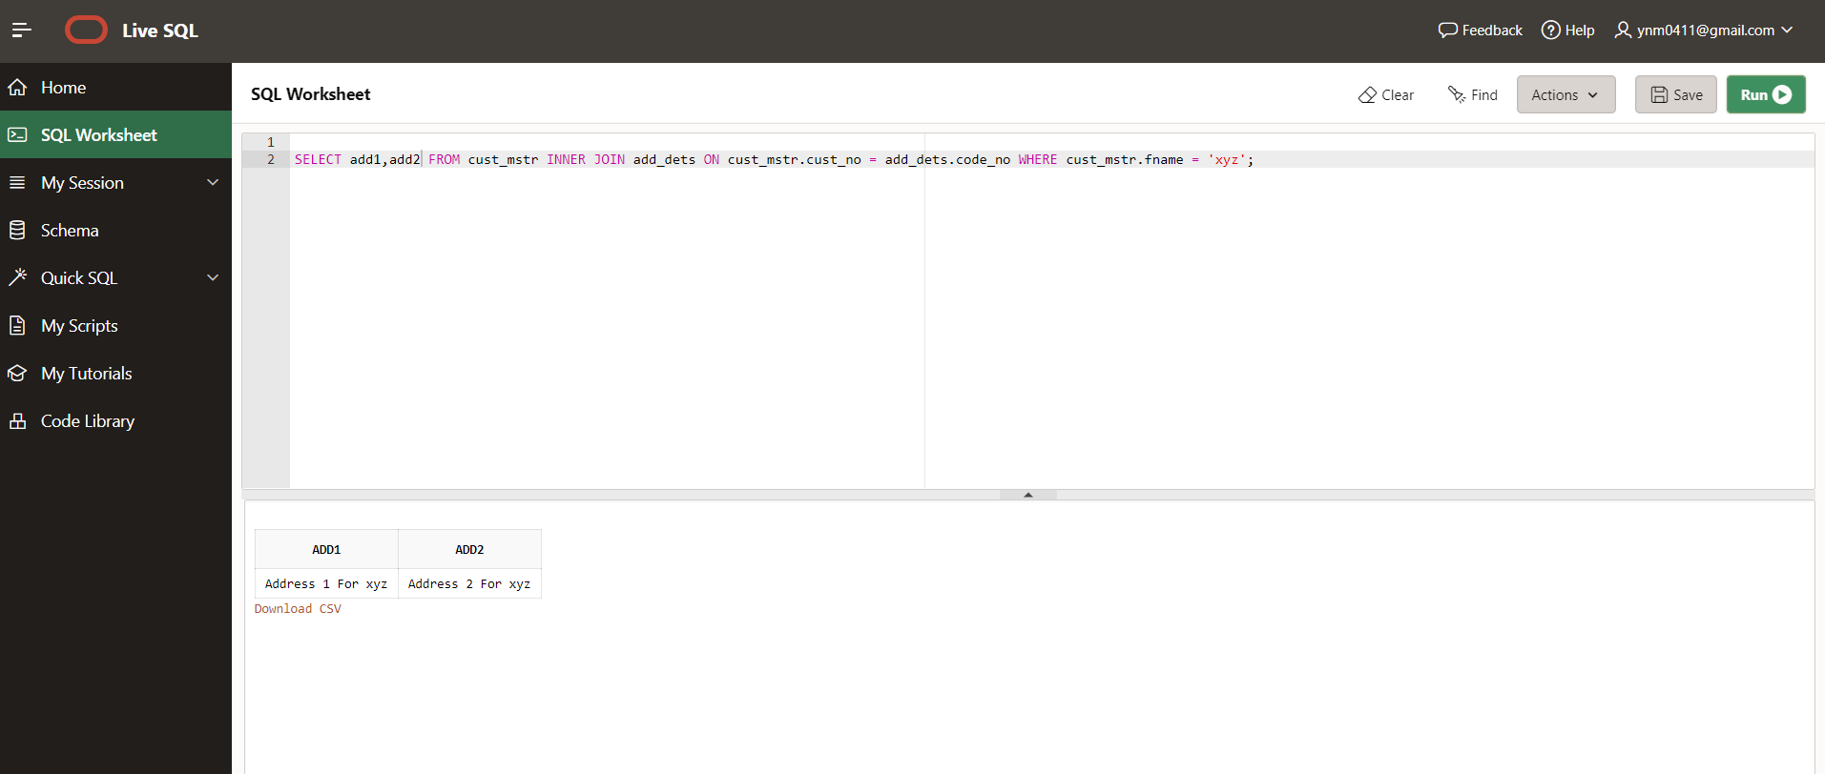

2.Create following Tables

cust_mstr(custno,fname,lname)

acc_fd_cust_dets(codeno,acc_fd_no)

fd_dets(fd_sr_no,amt)

Query: List the customer holding fixed deposit of amount more than 5000

Query Ans :

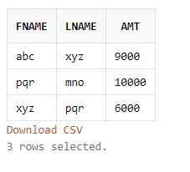

3. Create following Tables

emp_mstr(e_mpno,f_name,l_name,m_name,dept,desg,branch_no)

branch_mstr(name,b_no)

Query: List the employee details along with branch names to which they belong

Table emp_mstr:

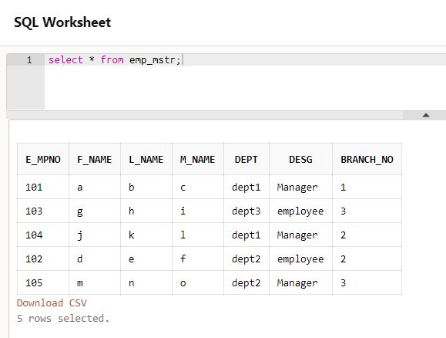

Table branch_mstr:

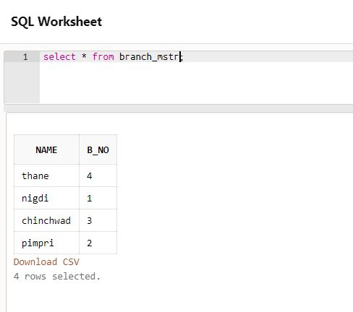

Query:

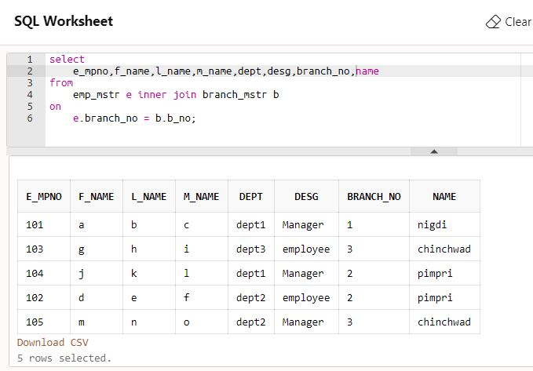

4. Create following Tables

emp_mstr(emp_no,f_name,l_name,m_name,dept)

cntc_dets(code_no,cntc_type,cntc_data)

Query: List the employee details along with contact details using left outer join & right join

Table emp_mstr: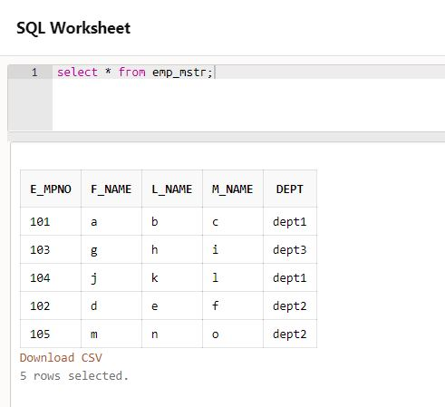

Table cntc_dets:

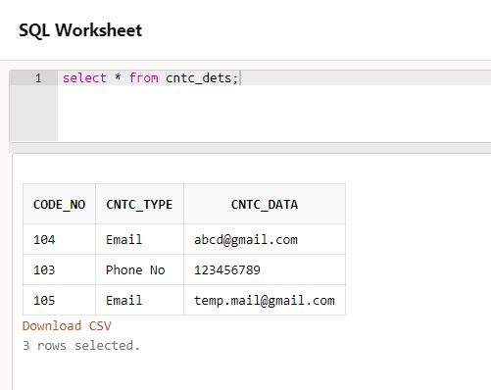

Left Join Query:

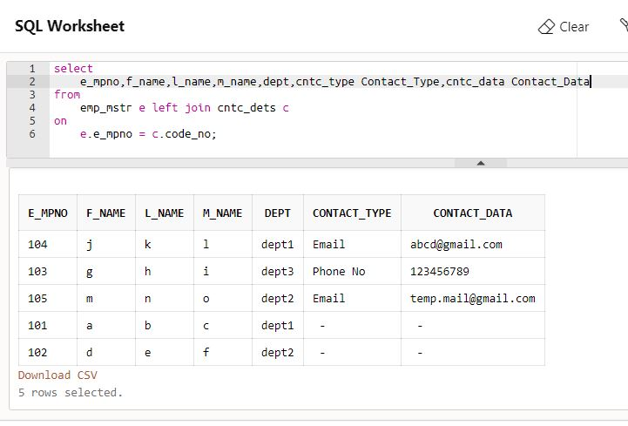

Right Join Query:

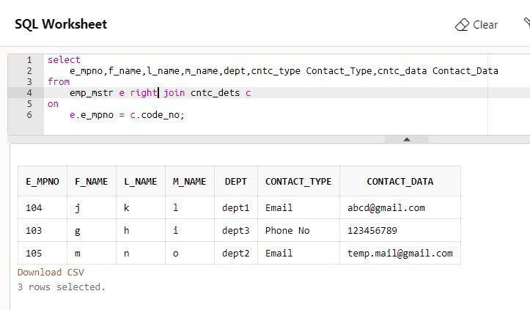

5. Create following Tables

cust_mstr(cust_no,fname,lname)

add_dets(code_no,pincode)

bank_branch(name,pincode) ///// Assumed Table

Query: List the customer who do not have bank branches in their vicinity.

Table cust_mstr:

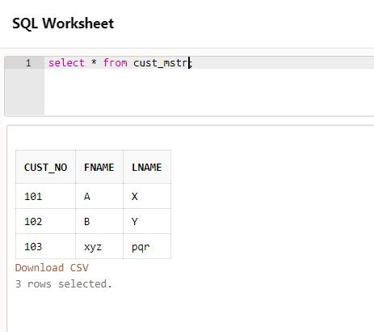

Table add_dets:

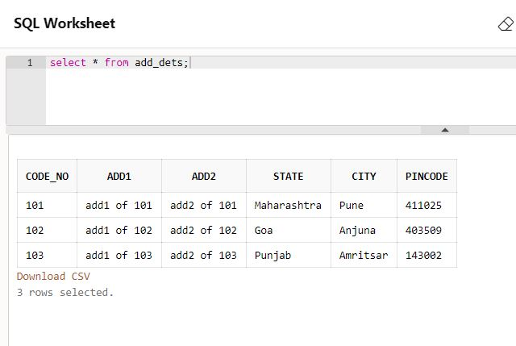

Table bank_branch:

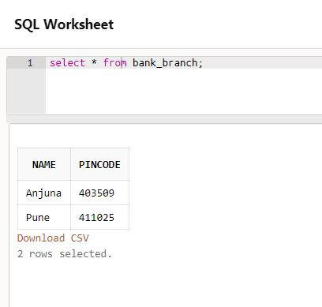

Query:

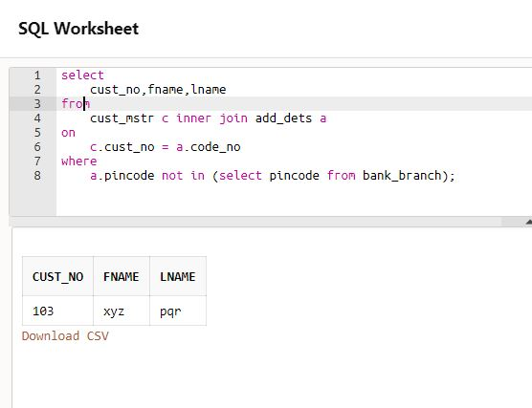

6. Queries on Views

a & c) Create Updateable View on borrower table by selecting any two columns and perform insert update delete operations

Table borrower:

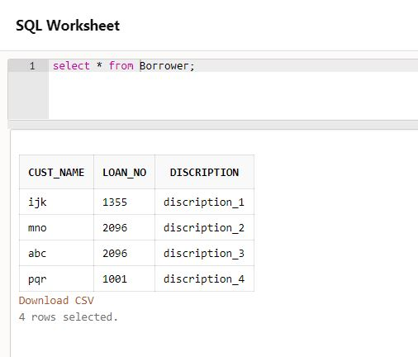

Create View Query:

create view

v1 as select CUST_NAME, LOAN_NO

from

BORROWER;

Insert Operation on View:

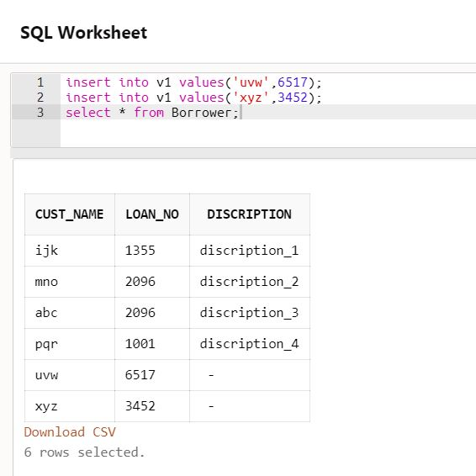

Update Operation on View: 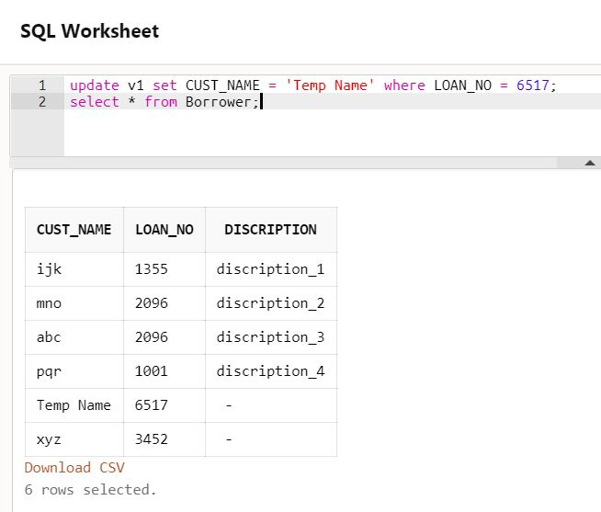

Delete Operation on View: 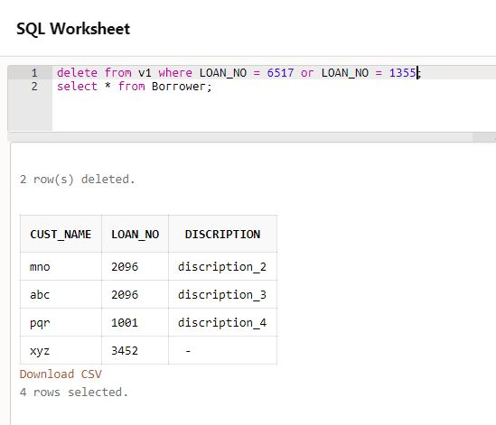

b) Create view on borrower and depositor table by selecting any one column from each table, perform insert update delete operations

Table borrower:

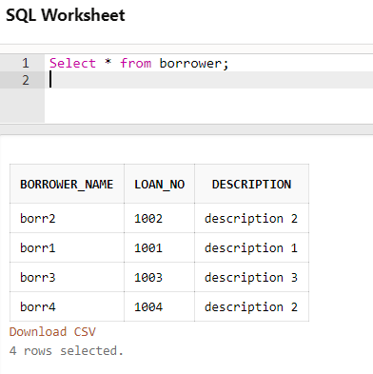

Table depositor:

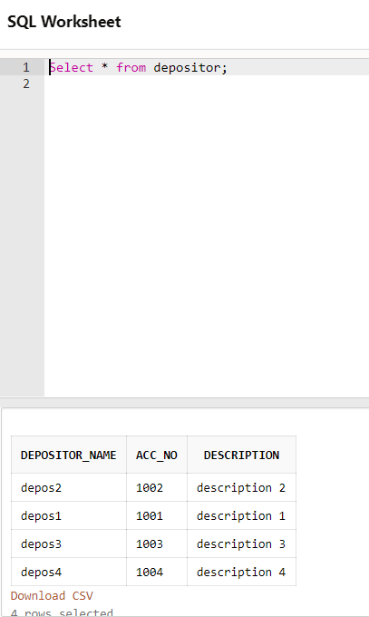

Create View Query:

create view

view1 as select acc_no, loan_no,borrower_name,depositor_name

from

borrower b, depositor d

where

d.ACC_NO = b.LOAN_NO;

Update Operation on View:

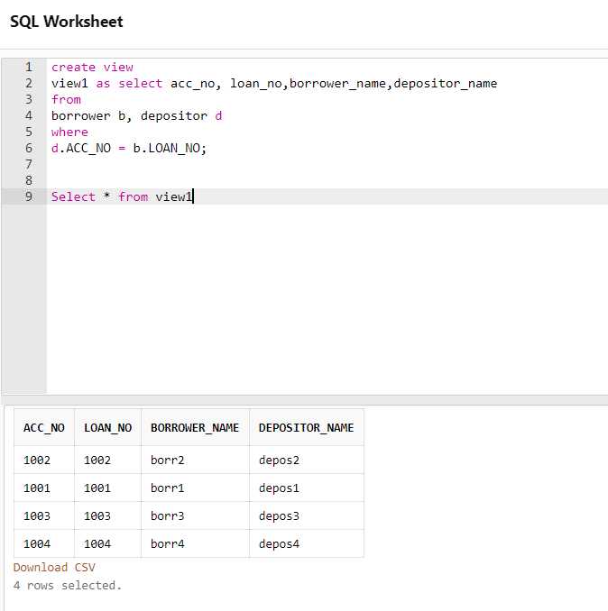

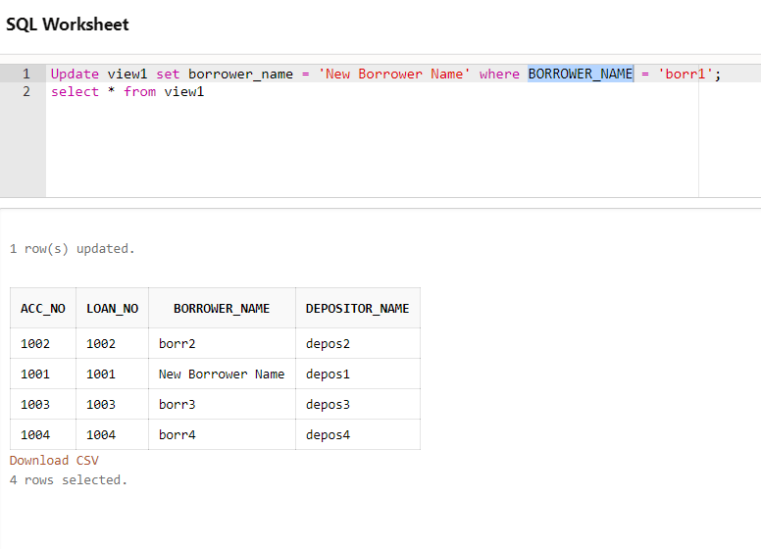

Delete Operation on View:

